A Proposal for Operating a Golf Course

Student’s Name
Department, University
Course Number and Name
Instructor’s Name
Date

A Proposal for Operating a Golf Course
Location
The purchase of Willow Park Golf Course found near Willow Lake Village would get done by our group. The golf course is situated near Crest Canyon territory and consists of a truck stable as well as upkeep structures. The location of the golf course is open with free transport getting offered. The process of offering free transport is a crucial way that allows most people to get attracted to the golf course.
Target Market
More than 200,000 retired folks visit Crest Canyon territory every year. The guests spend their money on food, housing and leisure activities in the region. These people provide more than $250 million to the golf course every year. People who love to play golf forms the main target market for the golf course company. Majority of people playing golf are old people who need ample time of fun and rest during vacation.
Customer Base
The customer base within the organization would get started within the neighborhood with people living inside the gated network, adult and youngsters’ kin getting incorporated. The required thoughts of organization get made leading to creation of a close network. The company has made targets that would make it become successful. First, it would ensure clients desires get met by the organization. Secondly, the use of vital partnerships to make players at the golf course venture into the game would get conducted. Thirdly, promote creation of a reliable neighborhood customer base. Fourthly, promote development of successful employees in the organization.
Start-up Summary
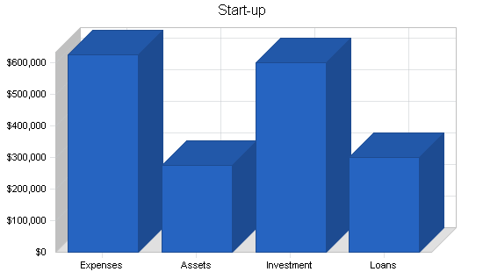
Marty Snyderman, Palmer St. Andrews and Luke Roth will each put resources into the endeavor. They will likewise make sure about a drawn out credit.
Start-up Expenses
Start-up
Requirements
Start-up Expenses
Legal | $5,000
Stationery etc. | $400
Brochures | $6,000
Pro Shop Setup | $50,000
Landscape Development and Repair | $280,000
Food Service Equipment | $20,000
Insurance | $4,000
Driving Range Equipment | $80,000
Lease Golf Carts | $10,000
Greens/Landscape Equipment | $170,000
Other | $0
Total Start-up Expenses | $625,400
Start-up Assets
Cash Required | $34,600
Start-up Inventory | $30,000
Other Current Assets | $0
Long-term Assets | $210,000
Total Assets | $274,600
Total Requirements | $900,000

Aim
Willow Park Golf Course aims at becoming famous to its guests and inhabitants around the region it serves. The provision of golfing activities will get promoted in all the areas of the company to ensure large number of people have opportunity of accessing recreational activities.
Summary of the company
The company gets situated in the Canyon zone and has many opening offices with excellent perspectives. There are truck stable, support structures and café within the golf course. The selling of the offices got done in the year by Claremont Properties a year later. The organization has been working on a renting plan to return offices. Structures like Pro shop, lunch room and truck animal dwelling place have got fixed by the new owners. The golf course requires effective maintenance to get performed for one month before it gets opened. Promotion of new structures and equipment would make the golf course have a new design of look.
Ownership of the Company
The main proprietors of the golf course include Luke Roth, Palmer St. Andrews and Marty Snyderman. The owners of the company have maintained an effective administration that has developed profits in the company after a long time. The three owners have ensured provision of great services gets used in making customer loyalty get promoted in the golf course.
Commodities and Amenities
The golf course will provide shops, bars and driving paths that would allow most visitors to like its environment. Golf playing fields has also got promoted leading to array of recreational activities getting provided. The shops and bars enable customers to make purchases of things they need. Driving paths make it possible for promotion of recreational activities like running to become possible.
Summary of the Market
Activities taking place at the golf course have been productive and fruitful because of improved business upswing that occurred in 1990s. The market consists of inhabitants and visitors from other places who needs to get served by the Willow Park Golf Course. The golf course contains many apartments, lodgings and offices that can inhabit many people. Renting of the rooms occurs at a higher rate every year. The enough space that the Willow Park contains can accommodate many people without any problem.
Segmentation of the Market
The clients of the organization can get partitioned in two groups namely, visitors and residents who have retired. The golf course is one of the growing retirement areas in the US. The population keeps growing every year at a pace 15%. Most customers visit the organization to enjoy the services and goods that gets offered. The retired visitors of close to 200,000 tend to enjoy the services and products provided at the golf course. Visitors and residents have opportunities of enjoying the activities that exists in the organization.
Market Analysis
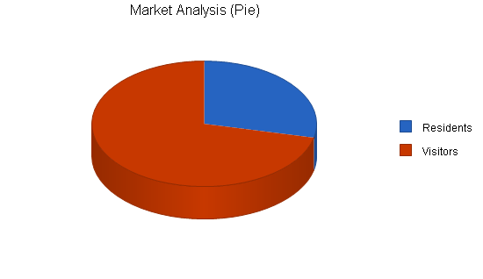
Market Analysis
 |  | Year 1 | Year 2 | Year 3 | Year 4 | Year 5
Potential Customers | Growth |  |  |  |  |  | CAGR
Residents | 15% | 80,000 | 92,000 | 105,800 | 121,670 | 139,921 | 15.00%
Visitors | 15% | 200,000 | 230,000 | 264,500 | 304,175 | 349,801 | 15.00%
Total | 15.00% | 280,000 | 322,000 | 370,300 | 425,845 | 489,722 | 15.00%

Summary of implementation and strategy
The golf course will perform its marketing to both the inhabitants as well as travellers who have resigned. The inhabitants of the golf course would receive low enrollment of the services that gets offered by the company. The visiting people would receive enrollment bundles for their daily participation in the organization. The bundles would help in keeping funds development amongst the natives and visitors of the golf course. The advertisement of the activities done at the golf course will get advertised to the inhabitants together with guests.
Strategy of marketing
Advertising of activities that gets conducted at the golf course would help in attracting large population. The inhabitants and visitors will have the opportunity of accessing the services and goods offered. The units of the Willow Park are spacious with affordable pricing that allows people to manage. Marketing that involves provision of credits is significant in enabling most consumers develop trust and loyalty for the golf course. The provision of extensions in form of credits would allow spending plan in the organization to get developed. The spending that occurs at the golf course would encourage most people in accessing the rooms and areas of playing within the company.
Competitive advantage
The activities that get conducted at the golf course have got overseen by an administration that has taken long time in performing administration activities. The founders of the golf course have maintained a strong process of overseeing all the activities that gets performed in organization. The administration has maintained appropriate leadership that has assisted in driving activities performed by the organization. The provision of free transportation within all the playing fields and lodgings make golf course appropriate for many visitors and inhabitants.
Financial Plan of the company
Willow Park Golf Course has a financial plan that expects fluctuation in sales and expenses that may affect the business performance. The organization has become developed physically with the target market fetching high income. The first year would involve establishment of maintenance course routines. These course routines would make the organization achieve maximum sales of their services. The reputation of the company would get developed and a steady growth would encourage more membership sales amongst the visiting golfers.
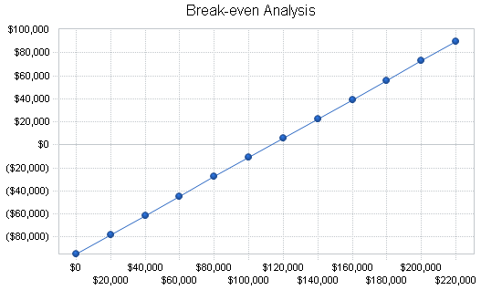
Projected Profit and Loss
The table below shows the projected profit and loss of the golf course for the next three years.
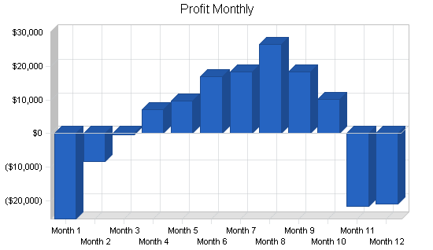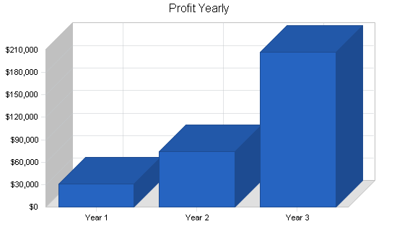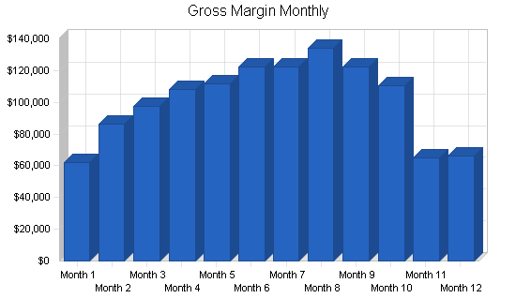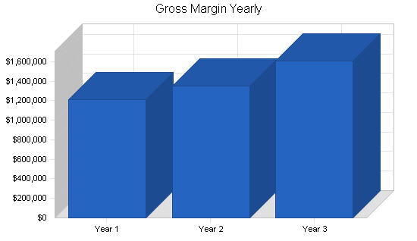
Sales Forecast
Sales
Memberships/Use Fees | 0% | $20,000 | $30,000 | $40,000 | $40,000 | $40,000 | $45,000 | $45,000 | $50,000 | $45,000 | $40,000 | $25,000 | $25,000
Day Use Fees (for 1 or more days) | 0% | $20,000 | $20,000 | $20,000 | $30,000 | $30,000 | $35,000 | $35,000 | $40,000 | $35,000 | $30,000 | $15,000 | $15,000
Golf Lessons | 0% | $8,000 | $16,000 | $20,000 | $20,000 | $25,000 | $25,000 | $25,000 | $25,000 | $25,000 | $25,000 | $10,000 | $10,000
Snacks | 0% | $16,000 | $24,000 | $24,000 | $24,000 | $24,000 | $24,000 | $24,000 | $24,000 | $24,000 | $24,000 | $12,000 | $12,000
Pro Shop | 0% | $4,000 | $10,000 | $8,000 | $7,000 | $7,000 | $4,000 | $5,000 | $6,000 | $5,000 | $4,500 | $8,000 | $12,000
Driving Range | 0% | $5,000 | $6,000 | $7,000 | $8,000 | $9,000 | $11,000 | $11,000 | $12,000 | $11,000 | $9,000 | $8,000 | $6,000
Total Sales |  | $73,000 | $106,000 | $119,000 | $129,000 | $135,000 | $144,000 | $145,000 | $157,000 | $145,000 | $132,500 | $78,000 | $80,000

Direct Cost of Sales |  | Month 1 | Month 2 | Month 3 | Month 4 | Month 5 | Month 6 | Month 7 | Month 8 | Month 9 | Month 10 | Month 11 | Month 12
Memberships/Use Fees |  | $0 | $0 | $0 | $0 | $0 | $0 | $0 | $0 | $0 | $0 | $0 | $0
Day Use Fees (for 1 or more days) |  | $0 | $0 | $0 | $0 | $0 | $0 | $0 | $0 | $0 | $0 | $0 | $0
Golf Lessons |  | $4,000 | $8,000 | $10,000 | $10,000 | $12,500 | $12,500 | $12,500 | $12,500 | $12,500 | $12,500 | $5,000 | $5,000
Snacks |  | $4,000 | $6,000 | $6,000 | $6,000 | $6,000 | $6,000 | $6,000 | $6,000 | $6,000 | $6,000 | $3,000 | $3,000
Pro Shop |  | $1,400 | $4,000 | $3,600 | $3,000 | $3,000 | $1,500 | $2,300 | $2,700 | $2,300 | $1,500 | $3,000 | $4,000
Driving Range |  | $1,750 | $1,750 | $1,750 | $1,750 | $1,750 | $1,750 | $1,750 | $1,750 | $1,750 | $1,750 | $1,750 | $1,750
Subtotal Direct Cost of Sales |  | $11,150 | $19,750 | $21,350 | $20,750 | $23,250 | $21,750 | $22,550 | $22,950 | $22,550 | $21,750 | $12,750 | $13,750
Projected Timesheet/Day
Willow Park Golf Course projected timesheet per day will be as follows. An individual timesheet will also be formulated to include a monthly payment schedule. The total amount payable to 13 workers will be around $2219 per day as should by the attached excel and the table below.
Column2 | Column3 | Column4 | Column5 | Column6 | Column7 | Column8 | Column9 | Column10 | Column11 | Column12 | Column13 | Column14
Willow Park Golf Course projected timesheet/head/DAY
Position | Date | Start time | finish | Regular Hours | overtime hours | Sick | Vaccation | Holiday | Others | Total hrs | Hourly rate | Total per day ($)
Maintenance Staff | 1/1/2021 | 7:30 AM | 2:30 PM | 7 | 0 | 0 | 0 | 0 | 0 | 7 | $11 | 77
Bag room / cart staff | 1/2/2021 | 8:30 AM | 3:30 PM | 7 | 0 | 0 | 0 | 0 | 0 | 7 | $13 | 91
Valet | 1/3/2021 | 9:30 AM | 4:30 PM | 7 | 0 | 0 | 0 | 0 | 0 | 7 | $18 | 126
Caddie | 1/4/2021 | 10:30 AM | 5:30 PM | 7 | 0 | 0 | 0 | 0 | 0 | 7 | $20 | 140
Waiter | 1/5/2021 | 11:30 AM | 6:30 PM | 7 | 0 | 0 | 0 | 0 | 0 | 7 | $20 | 140
Kitchen staff | 1/6/2021 | 12:30 PM | 7:30 PM | 7 | 0 | 0 | 0 | 0 | 0 | 7 | $22 | 154
Halfway house | 1/7/2021 | 1:30 PM | 8:30 PM | 7 | 0 | 0 | 0 | 0 | 0 | 7 | $20 | 140
security staff | 1/8/2021 | 2:30 PM | 9:30 PM | 7 | 0 | 0 | 0 | 0 | 0 | 7 | $18 | 126
Club Manager | 1/9/2021 | 3:30 PM | 10:30 PM | 7 | 0 | 0 | 0 | 0 | 0 | 7 | $35 | 245
Course Superintendent | 1/10/2021 | 4:30 PM | 11:30 PM | 7 | 0 | 0 | 0 | 0 | 0 | 7 | $35 | 245
External Manager | 1/11/2021 | 5:30 PM | 12:30 AM | 7 | 0 | 0 | 0 | 0 | 0 | 7 | $35 | 245
Accounting, marketing | 1/12/2021 | 6:30 PM | 1:30 AM | 7 | 0 | 0 | 0 | 0 | 0 | 7 | $35 | 245
Tournament Sales Staff | 1/13/2021 | 7:30 PM | 2:30 AM | 7 | 0 | 0 | 0 | 0 | 0 | 7 | $35 | 245
 |  |  |  |  |  |  | Total amount paid per day |  |  |  |  | 2219

